*Institute of Business Administration, Karachi*

**CS 416**

**Business Intelligence   
Final Exam  
Spring 2023**

**Date:** 21st May 2023  
**Duration:** 3 hours  
**Total Marks: 25%**

**Instructors:**  *Dr. Tariq Mahmood (Class # 70594)*  
*Ms. Abeera Tariq (Class # 70689)*

**REPORT TEMPLATE**

**Chosen Dataset:** Predicting Credit Card Customer Segmentation

**Link**: https://www.kaggle.com/datasets/thedevastator/predicting-credit-card-customer-attrition-with-m

**Team Members (name and erp):**

|  |  |  |
| --- | --- | --- |
| Sno. | Name | ERP |
| 1 | Muhammad Sumair | 22995 |
| 2 | Khansa Junaid | 23074 |

**Section A: Problem Statement**

**Type of customers and the trend in which they spend:** In this problem statement we are analyzing our customers first, which means that either the customer is male or female, is the customer married or divorced etc. When we study our customers detail, we can analyze the pattern on how they spend on themselves or their family. This problem statement can be very frustrating for the credit card company because, they would not know whom to give incentives, whom to cater more and provide better facilities without a proper analysis.

**Section B: Data Cleaning and EDA**

Firstly, we checked the data types of the columns to understand our dataset. For the further analysis we checked the mode, minimum and maximum values for some columns so that we can use them in our analysis. Moreover, there were no missing or null values in our dataset, instead there were some values like “unknown” in our dataset which we replaced with the null values so that we can treat them. We treated the following columns:

1. **Education_Level:** This column contains categorical values, which also included “Unknown”. We replaced it with the null value and the applied mode to it. In this way all the instances where there was “unknown”, we replaced it with the mode of the column which was “Graduate”.
2. **Marital_Status:** This column was also treated in the similar way as the education level because this also contained categorical values. We replaced the “unknown” values with the mode which was “Married”.
3. **Income_Category:** This column contained continuous values. We treated “unknown” values by grouping this column with the column ‘Card_Category’, so each type of could be represented by the range of income.

**Section C: Dashboards and Stories of Customer Profiles**

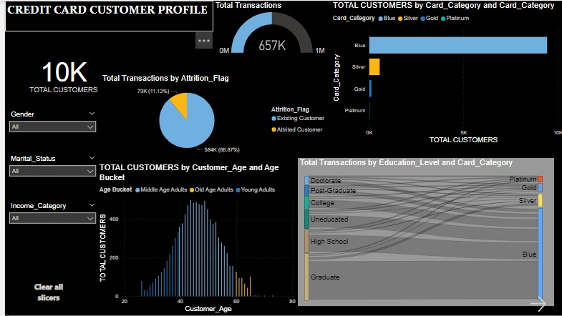

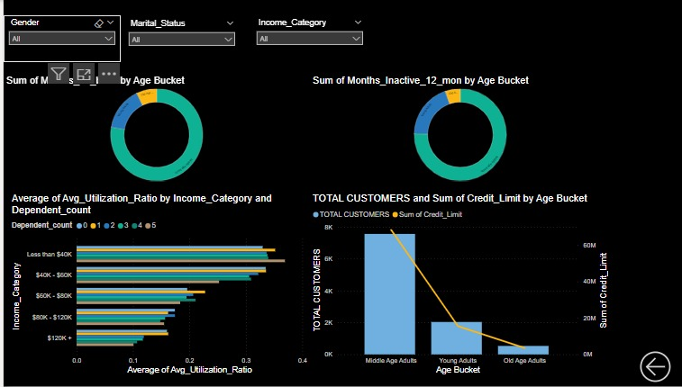

Our dashboard contains three drop-down menus, in which we can choose the gender of the customer, their marital status, and the range of incomes. Our graphs will change according to the options we have chosen in our drop-down menu. We have used DAX for calculating the total customers and the gauge for calculating the total number of transactions by all the customers. In the horizontal bar graph, we can see that we have different categories of cards, and we can also see the total transactions per card. Furthermore, we have made an age bucket where we have categorized our age into three different categories that are young people, middle aged people, and the old, aged people. With the help of this age bucket, we can see the total customers per age group. Moreover, we have used a Sankey graph for comparing the education level and the card category. We can see that graduates use blue cards which is the most in the data set, and the post-graduates use the platinum card.

In the second part of our dashboard, we are analyzing the credit limit with different age buckets, and the average utilization ratio with different income groups. In this way we can analyze which age group has the greatest credit limit and which income group has the greatest utilization ratio.

**Section D: Final Set of Insights – What is the answer to the problem statement?**

**Solutions:**

1) Firstly, the credit card company can see the spending patterns according to the marital status of the and the gender of the customers. We can see that majority of the customers are married and are male. So, we can say that the company can use this analysis to attract the customers that are not married by giving some incentives or leverages on the rate of interests or the card charges. On the other hand, the company can also give discounts on the bank charges to the married customers, keeping in mind their average utilization.

2) Moreover, there are different types of cards which the company can offer to the customers who have greater utilization because better card will mean better discounts on things and a greater credit limit. In this way, the people who are graduates and post-graduates will be able to get better cards because we can see that most of the customers are using the blue card, an only 20 people are using the platinum card and those are only post-graduates. So, providing better cards will automatically increase customer interaction.

3) Furthermore, we can see that there are young people with credit cards. Although young customers are less in number, but the company can start some sort of scheme to give a small benefit to them like discounts, a little increment in time for paying the remaining credit etc.

4) Similarly, we have also made an analysis on the income ranges of the people. We can see that people with less than 40K income are usually more likely to spend as their income is low and their average utilization of income is the highest. So, since they are spending at full capacity, the company should provide them with quarterly or yearly leverage in any taxes(company should bare a little amount so that these income bracket customers are attracted more) and bank charges.

5) Lastly, the company can offer a better category card like a gold one and can offer incentives in terms of low or no charges for opening the accounts on the occasions like women’s day, Mother’s Day etc so that more females are attracted and involved in opening the accounts and using their credit limit. This is because there are lower number of female customers as compared to the male customers.

**Section E: References**

If you used any links, make sure to enlist them in this section.